Predicting County-scale Maize Yields with Publicly Available Data

Authors
Zehui Jiang,¹ Chao Liu,² Nathan P. Hendricks,³ Baskar Ganapathysubramanian,⁴ Dermot J. Hayes,¹ Soumik Sarkar,¹*

Affiliations
¹ Department of Economics, Iowa State University, Ames, IA 50011
² Department of Energy and Power Engineering, Tsinghua University, Beijing 100084, China
³ Department of Agricultural Economics, Kansas State University, Manhattan, KS 66506
⁴ Department of Mechanical Engineering, Iowa State University, Ames, IA 50011
* Corresponding author. Email: soumiks@iastate.edu

Abstract
Accurate county-scale corn yield prediction critically impacts both policy as well as mercantile markets through providing valuable information about production and prices prior to harvest. Publicly available high-quality corn yield prediction can help address emergent information asymmetry problems and in doing so improve price efficiency in futures markets. We employ a deep Long Short-Term Memory (LSTM) network to predict corn yields, specifically focusing on two aspects: (a) county-level prediction across 10 states of the corn belt in the United States of America, and (2) pre-harvest prediction with monthly updates from August. We show that successful deployment of deep learning concepts is possible by careful selection of cross sectional time series of county-level corn yield and hourly weather data. The results show promising predictive power relative to existing survey based methods, and sets the foundation for a publicly available county yield prediction effort that complements USDA NASS.

Introduction
In the 2001 Nobel Prize winning paper “The Market for Lemons”¹, George Akerlof shows that in a second-hand car market where asymmetric information exists, sellers know the quality of their cars but the buyers do not. Buyers offer a price based on the expected quality of the car. As a result, sellers of the high-quality cars worth more than the average price will exit the market, driving the proportion of low value cars up, thus pushing offer prices further down. Eventually, only “lemons” are left in the market and the market collapses. Akerlof shows that the key to this collapse is information asymmetry (i.e., sellers have more information than buyers).

One solution to information asymmetry is to provide public information to all participants in the market at the same time. The United States Department of Agriculture (USDA) has been predicting national corn yield and production every year since 1964, providing consistent, publically available and unbiased information to all stakeholders. The main method they use to create this information is survey based. Additionally, they deploy enumerators who make field visits in important corn production areas. The results from this traditional statistical method is subjective since it is the farmer’s estimation of his/her yield at the point the survey was taken. USDA has tried new sources of data collection including satellite imagery from MODIS (moderate resolution imaging spectroradiometer) from NASA. However, as of fall 2018, USDA continues to rely primarily on the survey-based data.

Several private companies, such as Lanworth², Tellus Labs³ and Climate Corp⁴, are probably in a position to improve on the USDA survey. In contrast with the monthly state-level prediction from USDA, these companies set up plant growth models based on weather information and expert knowledge, monitor satellite imagery and weather patterns, and incorporate as many independent lines of evidence as possible into their estimates to produce daily yield estimates of both individual farms as well as aggregated estimates at the county scale. Corn futures traders in the Chicago Mercantile Exchange who have preferential access to this information may be in a position to make profitable trades to the detriment of traders who do not have access. Corn futures prices have a strong connection with expected corn yield. If a company or individual can predict yield more precisely, they will have better information about futures prices and can speculate better in the futures market.

Our motivation is to provide the public with a high-quality corn yield prediction that can substitute for private information from companies, thus eliminating information asymmetry in the corn futures market in the long run. We attempt to do so by improving the accuracy and quality of USDA predictions. Two limitations of USDA predictions are that they only offer state-level, but not county level predictions, and that USDA only publishes four monthly prediction reports annually instead of a daily early prediction during the whole corn growing season. In this paper, we utilize modern data science techniques to provide monthly Corn Belt corn yield predictions at the county level. This method can also be used to provide a daily update on expected yield.

1.1 Background Knowledge
Corn is mainly grown in the midwestern part of the United State (the green area in Figure 1(a)), in an area called the corn-belt. The region is characterized by level land, deep fertile soils, and high organic soil concentration⁵. The corn-belt includes Iowa, Illinois, Indiana, southern Michigan, western Ohio, eastern Nebraska, eastern Kansas, southern Minnesota and parts of Missouri. Corn is typically planted in April and harvested in October. The USDA reports the nationwide county level corn yield in late February of the following year. The USDA provides a monthly estimate of expected yield beginning in August.

Beginning in the early 2000, groups started considering traditional machine learning (ML) methods for yield prediction. Early research activities created ML models using discrete weather variables for yield prediction. These models, however, do not account for the long-term dependencies between (continuous) weather variables and final yield. A pressing question has been to develop and deploy methods that could provide insight into whether and how each point along the weather time series influences the final yield. Here, we use Long Short-Term Memory (LSTM)⁶, a special form of Recurrent Neural Network (RNN)^{7,8,9} to accomplish this. The efficiency of LSTM networks in capturing long-term dependencies in multivariate time series with complex inner relations makes them a natural fit for this problem. Although LSTM is a promising and very popular deep learning approach, its use has remained particularly focused to applications in natural language processing. Our work is one of the first to apply LSTM in crop yield prediction, illustrating its potential for solving other prediction problems, and to improve the accuracy of publicly available corn yield prediction.

1.2 Related Work

The selection of variables plays a prominent part in determining the quality of any predictive model. In this context, production agriculture contains a rich body of work that provides domain knowledge regarding important input variable in selection and preprocessing. For instance, the work ¹⁰ (“The Seven Wonders of the Corn Yield World”), indicates that weather holds the first place among the seven “wonders” affecting corn yield. The key determinants of weather include rain, temperature, wind and humidity. Early work focused on fitting linear models to explore trends and patterns in crop yields associated with weather^{11,12,} ¹³. Recent work has shown that some weather variables (like temperature and water/drought) have nonlinear effects on corn yield¹⁴,¹⁵.

This sets the stage for ML models that can model both linear and non-linear effects without any hand crafting of parametrization. Some of the early work includes work by Monisha and Robert (2004) who used an artificial neural network (ANN) model with rainfall data to predict corn and soybean yield¹⁶. Newlands and Townley-Smith (2010) apply a Bayesian Network (BN) to crop yield prediction and used it to produce distributional forecasts of energy crop yield¹⁷, and this was extended by Chawla et. al (2016) showed to predict county-level corn yield ¹⁸. More recently, Kim et al. (2016) use four machine learning approaches for corn yield estimation in Iowa—SVM (Support Vector Machine), RF (Random Forest), ERT (Extremely Randomized Trees), and DL (Deep Learning)—and utilize satellite images and climate data as explanatory variables¹⁹. With differences between their predictions and USDA statistics about 6%–8%, they persuasively conclude that machine learning is a viable option for crop yield modeling. These prior efforts set the stage for a continuous variable based ML yield prediction model that can also provide in-season monthly updates to the predicted crop yield.

Results
Data Collection
We collected publicly available historical data for ten states in the Corn Belt: Iowa, Illinois, Indiana, Minnesota, Nebraska, Kansas, Michigan, Ohio, Missouri, and South Dakota. All data is from 1980 to 2016. The data range is restricted due to availability of weather data. The first 33 years are selected as the training data, while the most recent four years are used as testing data to explore the model’s predictive capability. As Iowa is the dominant corn planting state, we use it as our primary model testing state. The data collection process consists of two parts: collection of raw data and feature selection and preprocessing.

Yield Data. Historical corn yield data is collected through Quick Stats from the National Statistics Service (NASS)²⁰ for 37 years. Corn yield data is a yearly collected data at county level. Taking Iowa as an example, this data consists of yearly information for each of the 99 counties in Iowa, resulting in 37x99 = 3663 records of historical yield data available, with 3267 of them acting as training samples. It should be emphasized that corn yields increase through time due to genetic gain. Therefore, we adjust the historical corn yield onto a uniform projected yield (similar to ‘inflation adjusted’ costs). We consider two methods of this adjustment: In the first approach we use a 1.5% annual yield increase, which is the standard number used by agricultural experts [REF]. In the second approach, instead of a percentage increase, we use an absolute increase corresponding to genetic gain of 2.5 bu/ac per year from 1980 to 2000 and 4.67 bu/ac per year after 2000²¹.

Weather & Soil Data. Three types of input variables associated closely with corn yield are available. They are hourly weather data, soil quality data and soil moisture data. The hourly weather data was purchased from a weather data company – Weather Underground²². The data is a quality controlled and each data point is a 19x19 mile area spatially representative snapshot. We note that this is more accurate than the commonly used weather station data which measures weather at one central point. We use weather data from April to October to reflect the growing season in the corn-belt.

Weather variables impact yield in non-trivial ways. For instance, rainfall in the growing season may result in high yields, but extensive rainfall and flooding resulting in standing water can significantly reduce yield. Similarly, high wind speed can damage corn crops by uprooting plants, but in moderation can increase evapotranspiration. Temperature has the most complex impact on yield with the maximum, minimum and the mean temperature all influencing yields. Plant physiologists use a concept called Growing Degree Days (GDDs⁾²³ to quantify this complex impact of temperature on plant development rates and yield. GDD are calculated as where = min(86ºF, daily maximum temperature), and = max(50ºF, daily minimum temperature). Here, is the minimal temperature (set to 50ºF for corn) over which photosynthesis is active triggering growth. Finally, we note that the cumulative GDD seen by the plant also influences the final yield.

Soil moisture has a critical impact on corn yield. The Palmer Drought Severity Index (PDSI)²⁴ is a long term cumulative measure of water availability in the soil. It is a standardized index that spans -10 (dry) to +10 (wet). 0 stands for a normal moisture condition, negative shows the soil is dry and positive means there is surplus water. PDSI uses temperature data and a physical water balance model to capture the basic effect of global warming on drought. PDSI is monthly data downloaded from the National Oceanic and Atmospheric Administration (NOAA) at the Crop Reporting District (CRD) level (Figure 1(c)). We assign PDSI values to all counties within each district (i.e. counties in the same CRD has the same PDSI value).

Finally, soil quality²⁵ data is collected from the SSURGO database²⁶ (database for storing gridded soil survey results) and aggregated to the county level using only areas classified as cropland according to the NLCD²⁷ (National Land Cover Database). For continuous variables, we aggregated to the county level by taking the spatial average. The data covers the whole corn-belt region at county level. There are over one hundred variables in this dataset. Each variable is a constant number for each county, since soil quality typically does not change over time. We pick fourteen variables most related to corn yield (Figure 2(a)) from this dataset. Among these, root zone for water storage and soil drought vulnerability are considered the most two significant soil variables.

Variable selection and data preprocessing
The time series of input variables are expressed in a daily format. Each county for each year is one data point containing yield as the output variable and the corresponding input time series collected from April to October. Considered on a daily basis, the length of the input time series, , is t=214. Choosing a finer granularity (i.e. hourly data) for the input was not promising due to two reasons, (a) with only 3,267 training samples, considering hourly time series (with a corresponding t=5,136) let to too many parameters to viably estimate, and (b) daily weather data is able to track plant physiological response fairly well [ref].

Variable Selection. There are totally twenty-eight candidate input variables. In addition to the fourteen soil quality variables and PDSI, we also include max/min/mean temperature for each day, total daily rainfall, daily average wind speed, max rainfall during the day, accumulated rainfall and GDD accumulated up to that date. Since July is considered to be the most important month for corn growth²⁸, rainfall and max temperature in July are also included. The ratio of acres planted for corn divided by the total acres planted may also influence the corn yield since farmers in corn intensive counties will specialize in corn management techniques and management. Two interaction terms (max temperature x soil droughty and maxxPDSI) are also included. The idea behind this is that at high temperatures soil moisture will be more important than at low temperatures.

First, we trained the model using all these 28 variables. Our county level yield predictions turned out to be almost constant (at the county average). We subsequently used MRMR²⁹ (minimum redundancy maximum relevance), a feature selection method introduced in Peng (2005). Using MRMR, we eliminated variables with low rank. Additionally we calculated the correlation between weather variables and eliminated the highly correlated ones. Based on some additional model exploration and domain expertise, we arrived at the “best” ten input variables for corn yield prediction. These are max/min/mean temperature, total daily rainfall, wind speed, soil root space for holding water (rootznaws), soil droughty vulnerability (droughty), PDSI, accumulative rainfall and GDD.

Data Augmentation. Even when using daily as opposed to hourly input series, 3,267 training samples are still not good enough for good training. A standard approach is to perform data augmentation [REF]. We perform data augmentation by considering pairs of nearby counties (in the same CRD) and take the average of their yield and input variables respectively, to create a new sample data. With this strategy, the total number of training data increases up to 70,026.

Ten input variable sequences are stored in the format of 3D tensor cube for LSTM training. Figure 2 is an example of 3D tensor cube. X-axis indicates the number of the input variables, Y-axis is the length of the time series and Z-axis shows the number of samples. Hence the dimension of our 3D tensor is.

Yield prediction results
We train separate models for each state with both percentage and constant adjustment. Our results indicate that percentage adjustment works much better for the whole Corn Belt. Figure 3 shows our county-level prediction result for several states. Absolute errors between our prediction and the true value is calculated and represented as dots in the figures for each year. The results indicate that over 80% of the county-level yield prediction fall into the +/-20 bushels/acre region away from the true yield. We emphasize that this is a very significant result, especially considering that no farm management data (that are not typically available to the public) is used.

We also aggregate the prediction to state level for each state to compare with the USDA prediction in November. In order to make the comparison clear, we only present the mean absolute error (MAE) and mean absolute percentage error (MAPE) of the prediction for 2013–2016. According to the results listed in Table 1(a), all the MAPEs are less than 7% with most of them are less than 3%, indicating excellent predictive accuracy. We note that half of the predictions beat the USDA prediction, while the MAPE of Kansas, Missouri, and South Dakota was about 5%–7%, which are the states that only include less than 40 counties for testing. When we aggregate the results to the whole Corn Belt as shown in Table 1, the result are even better. The prediction error is less than 1 bushel/acre and also beats the USDA prediction.

Early Prediction
In order to make a comprehensive comparison between USDA and our model, we retrained our model for Iowa using three sets of partially available information , specifically with data available until August, September and October respectively (i.e. y=122, 153 and 183 for the 3D tensor cube). These trained models make in-season predictions of final yield based on information available to them until that point. Figure 4 summarizes the prediction results of USDA and our LSTM model. It is clear that most of our early prediction results are better than the USDA prediction. We also observe that predictions in November are usually worse than in October. This is because we could not know the accurate harvest date for each year and data after the harvest date is included in the training data. Therefore, the resulting redundant and noisy information have been learned by the model and that influences the final prediction. This comparison indicates the power of our model in early prediction and the ability to beat USDA with limited data.

Discussion
This paper describes the prediction of county-level corn yields in the Corn Belt area using the deep learning method called LSTM. We only leverage historical weather and publicly available yield data to learn such models that are demonstrated to be a powerful option for crop yield prediction. Results show that our LSTM model can provide useful early prediction and accurate county-level corn yield prediction in the US Corn-Belt without private farm management data and the genetic information of seeds. Our LSTM models seem to be a good supplement and improvement to the USDA prediction that will contribute to eliminating the information asymmetry problem that arises from the success of private companies in crop yield prediction. @Dermot – could you please mention briefly regarding your plan to provide regular predictions to the public?

Methods
Problem Formulation
As described in the Results section, the variable to be predicted in this work is the yield, which is a yearly data and defined at county level in this work. The input variable for the prediction model include hourly weather data, soil quality data, and soil moisture data. Therefore, the yield prediction is defined as $Y=f(X)$, where Y is the vector of the yield in county-level, X is the input matrix with multivariate time-series data.

To best extract the information embedded in the time-series data, Long short-term memory (LSTM) networks are selected as it is efficient in dealing with time-series data and extracting recurrent features in relatively long-term time-series data. With this setup, early prediction can also be formulated using the available time-series data, say the weather data till August can be used for early prediction in August.

Recurrent Neural Network
LSTM is based on Recurrent Neural Network (RNN) and with a special memory cell to handle the features needed to be remembered and those should be forgot [?]. In general, RNN is a family of neural networks for processing sequential data. It is typically used in text prediction and speech recognition.

For a regular RNN, the network consists of three layers: an input layer, a hidden layer and an output layer. is the input sequence, is the output sequence and is a series of hidden states. The number of the hidden layers is not constrained to one. In the deep learning recurrent neural networks, the number of the hidden layers can reach eight or more. Adding hidden layers can help to study the more complex structure of the model, but also requires more data. are shared weights that we need to learn. And there is an activation function that , which should be chosen before learning the networks. The corn yield prediction problem could not fit into a regular RNN, therefore we use the many-to-one RNN model here. Many-to-one RNN model is suitable when there is sequence input with one output, thus it is perfectly match with our data format described in the data section.

Long short-term memory (LSTM)
The mathematical challenge of learning long-term dependencies in recurrent networks is called the “vanishing gradient problem.” As we propagate the gradient back in time, the magnitude quickly decreases. That is to say, as the input sequence gets longer, it becomes more difficult to capture the influence from the first stage. The gradients to the first several input points vanish and are approximately equal to zero (rarely the gradients will explode with much damage to the optimization). Therefore, a special RNN model called Long Short-Term Memory (LSTM) was developed. LSTM uses the identity function with a derivative of one. As a result, the back propagated gradient remains constant instead of vanishing or exploding when passing through. Clearly LSTM has a more complex structure to capture the recursive relationship between the input and hidden layer. We call the cell between the input and hidden layer LSTM cell.
LSTM adds a new sequence called cell state to RNN. Cell state is a space specifically designed for storing past information (i.e., the memory space) that mimics the way the human brain manipulates information when making decision. The left part of the cell is the forget gate layer, which makes the decision whether past information stored in the cell state should be discarded or not. The middle is the input gate layer, which decides whether new information from the input should be added or not. The operation is executed to update old cell state to . This is when old information is dropped and new information added. We can get the output as by operating the right part, which is the same process as regular RNN.

In summary, the behavior of the memory cell is determined by three gates: input, output, and forget. The updated equations are as follows:
where all are learnable parameters and the operator denotes the element-wise multiplication.

Fig. 2 shows the structure of our final LSTM model used for county-level corn yield prediction in the Corn Belt.

Training of LSTM
Loss function is a measure of how good a prediction model does in terms of being able to predict the expected outcome. The loss function we picked for our LSTM model is the mean squared error (MSE). The target of training the prediction model is to find parameters that could achieve the minimum point of the loss function, thus turning it into an optimization problem. The algorithm to learn the recurrent neural network is gradient descent³⁰ and back-propagation through time³¹ (BPTT). Gradient descent is one of the most popular algorithms to perform optimization. It is an efficient algorithm to search for the local minimum of the loss function. The BPTT algorithm is used to compute the gradient for the equation and the loss function. The core idea behind BPTT is the composite function chain rule. The nodes of our computational graph include the parameters and constant terms as well as the sequence of nodes indexed by for and . Once the gradients on the internal nodes of the computational graph are obtained, we can obtain the gradients on the parameter nodes. The parameters are shared across time steps. Given a starting point, calculating the gradient of that point and searching in the direction of the negative gradient is the fastest way to search for a local minimum. Then we can update the parameters with iterations of the gradient descent optimizer by searching for a smaller local minimum.

Model Settings
There are still some questions about the model settings. Should we use one, two, or more hidden layers? Will more related input variables improve the prediction? Will more created training samples generated with combinations described in the data section improve the prediction? We tried all these different settings in the Iowa model and the results showed that the best model is the one with two hidden layers, ten variables picked up in the data augmentation section, and two county combination samples added, which totals 19734 samples.

New problem is also arisen. How should we expand the model to other states in the Corn Belt from Iowa? We have three choices: (a) apply the “best” Iowa model to all other states; (b) train models separately for each state; and, (c) train the “best” model with all data from the Corn Belt. Undoubtedly, Iowa model performs badly on other states. The last choice is proven improper either. Even though we include all data from different states, many unknown variables correlated with each state did not get included in the model. LSTM then only keeps the common information and throws away all other noises, leading to the result that our big Corn Belt model learns less information than does a separate model for each state. Therefore, the best choice is to train models separately for each state.

Implementation
Our LSTM model was learned using the Keras³² Python package on top of Theano³³ backend. We assigned a linear relation between the hidden and output layers. There are several choices for gradient descent optimizer in Keras. We tried both Stochastic Gradient Descent (SGD) and RMSprop optimizer. Our final LSTM model used RMSprop optimizer as this optimizer is usually a good choice for RNNs. Besides the parameters that we need to learn from the data, there is also another kind of parameter specified manually for LSTM models, called a hyperparameter. A model hyperparameter is a configuration that is external to the model whose value cannot be estimated from data. Hyperparameter searching is an important process before the commencement of the learning process. The choice of the hyperparameter influences the learning result.

The hyperparameters that we decided manually for our LSTM model include the number of hidden nodes within each hidden layer, batch size, dropout rate, learning rate, momentum, and decay rate. Batch size is the number of training examples utilized in one iteration of SGD or RMSprop optimizer. The higher the batch size, the more memory space needed. Dropout is a technique where randomly selected neurons are ignored during training. A 0.2 dropout rate means that one in five hidden neurons will be randomly excluded from each updated cycle. Dropout could make the network less sensitive to the specific weights of neurons, and in turn solve the overfitting problem. Learning rate, momentum, and decay rate are important parameters for SGD optimizer. They would decide the speed of convergence of the network. The learning rate is how quickly a network abandons old beliefs for new ones. With a large learning rate, we take huge jumps to reach the bottom. There is also a possibility that we will overshoot the global minima (bottom) and end up on the other side of the pit instead of the bottom. Thus, we will never be able to converge to the global minima, but instead wander around. However, it will take too much time to converge if the learning rate is too small. Hence, it is often useful to reduce the learning rate as the training progresses, which is what the decay rate is used for. Momentum is an argument in SGD optimizer to obtain faster convergence. RMSprop optimizer is similar to the SGD optimizer with momentum. It uses a moving average of squared gradients to normalize the gradient itself. We only need to define the learning rate for RMSprop optimizer.
Nobody has the ability to know the best value for a model hyperparameter of a given problem. We may use rules of thumb, copy values used on other problems, or search for the best value by trial and error. What we did was assign a set of numbers by experience for these hyperparameters and let the machine randomly pick one value in the set for each hyperparameter. The choice sets include: (1) hidden nodes, [8, 16, 32, 64, 128, 214], (2) batch size, [16, 64, 128, 512, 1024], (3) dropout rate, [0.0, 0.1, 0.2, 0.3, 0.4, 0.5, 0.6, 0.7], (4) learning rate, [1e-07, 1e-06, 1e-05, 1e-04, 0.001], (5) momentum, [0.0001, 0.001, 0.01,0.05, 0.1], and (6) decay, [0.0001, 0.001, 0.01,0.05, 0.1]. For each choice set, SGD and RMSprop optimizers are tested. Usually after searching for over 300 models with different combinations of hyperparameter settings, we can find the ‘best’ model and the corresponding ‘best’ hyperparameters.

References and Notes
1. George, A. A. The Market for “Lemons”: Quality Uncertainty and the Market Mechanism. The Quarterly Journal of Economics Vol. 84, 488-500 (1970).
2. Thomas Reuters, Lanworth Crop Production Forecasts. Available at https://www.thomsonreuters.com/en.html
3. Tellus Labs, Kernel. Available at https://telluslabs.com/pages/kernel
4. Climate Corp. Available at https://www.climate.com/
5. Corn Belt. Encyclopedia Britannica Online.
6. Hochreiter, S. & Schmidhuber, J. Long Short-Term Memory. Neural Computation 9(8): 1735-1780 (1997).
7. Goodfellow, I., Bengio, Y. & Courville, A. Deep Learning The MIT Press (2016).
8. Michael, H. & Peter, S. Recurrent Neural Networks for Time Series Classification. Neurocomputing 50(C): 223-235 (2003).
9. Che, Z., Sanjay, P., Cho, K., Sontag, D. & Liu, Y. Recurrent Neural Networks for Multivariate Time Series with Missing Values. ICLR (2017).
10. Fred, B. The Seven Wonders of the Corn Yield World. Institute of Ag Professionals (2008).
11. Foote, R.J. & Bean, L.H. Are Yearly Variations in Crop Yields Really Random? Journal of Agricultural Economic Resources 3: 23–30 (1951).
12. Kaylen, M.S. & Koroma, S.S. Trend, Weather Variables, and the Distribution of U.S. Corn Yields. Review of Agricultural Economics, Oxford University Press on behalf of Agricultural & Applied Economics Association 13: 249–258 (1991).
13. Deschênes, O. & Greenstone, M. The Economic Impacts of Climate Change: Evidence from Agricultural Output and Random Fluctuations in Weather. The American Economic Review 97: 354–385 (2007).
14. Schlenker, W. & Roberts, M.J. Nonlinear Temperature Effects Indicate Severe Damages to U.S. Crop Yields under Climate Change. Proceedings of the National Academy of Sciences 106: 15594–15598 (2009).
15. Yu, T. Three essays on weather and crop yield. Ph.D. thesis, Economics, Iowa State University (2011).
16. Monisha, K., Robert, L. & Charles, W. Artificial neural networks for corn and soybean yield prediction. Agricultural Systems 85: 1-18 (2005).
17. Newlands, N. K. & Townley-Smith, L. Predicting energy crop yield using Bayesian networks. Proceedings of the Fifth IASTED International Conference, Computational Intelligence 107-112 (2010).
18. Chawla, V., Naik, H.S., Akintayo, A., Hayes, D., Schnable, P., Ganapathysubramanian, B., and Sarkar, S. “A Bayesian Network Approach to County-Level Corn Yield Prediction using Historical Data and Expert Knowledge.” KDD 16 Workshop: Data Science for Food, Energy and Water, San Francisco (ISBN: 978-1-4503-2138-9) DOI: 10.1145/1235 (2016).
19. Kim, N.L. and Lee, Y-W. “Machine Learning Approaches to Corn Yield Estimation Using Satellite Images and Climate Data: A Case of Iowa State.” Journal of the Korean Society of Surveying, Geodesy, Photogrammetry and Cartography 34(4): 383–390 (2016).
20. USDA., NASS Quickstats. Available at http://quickstats.nass.usda.gov/
21. Li, L. The Impact of Weather and Weather Extremes on Corn Yields. Ph.D. thesis, Economics, Iowa State University (2015).
22. Weather Underground. Available at https://www.wunderground.com/history/
23. NDAWN Center. Available at https://ndawn.ndsu.nodak.edu/help-corn-growing-degree-days.html/
24. Historical Palmer Drought Indices, NOAA. Available at https://www.ncdc.noaa.gov/temp-and-precip/drought/historical-palmers/
25. AgriData, NRCS Soil Map Data. Available at https://www.agridatainc.com/Home/Products/Surety/NRCS%20Online%20Soil%20Maps
26. USDA., SSURGO. Available at https://www.nrcs.usda.gov/wps/portal/nrcs/detail/soils/survey/geo/?cid=nrcs142p2_053631
27. U.S. Geological Survey, Department of the Interior. Available at https://catalog.data.gov/dataset/national-land-cover-database-nlcd-land-cover-collection
28. Juan, J.A., Fazli, M. & Zhou, X.M. Climate change, weather variability and corn yield at a higher latitude locale, Southwestern Quebec. Climatic Change 88: 187-197 (2008).
29. Peng, H., Long, F. & Ding, C. Feature Selection Based on Mutual Information: Criteria of Max-Dependency, Max-Relevance, and Min-Redundancy. IEEE Transactions on Pattern Analysis and Machine Intelligence Vol. 27, No. 8 (2005).
30. Léon, B. Online Algorithms and Stochastic Approximations. Online Learning and Neural Networks. Cambridge University Press (1998).
31. Mozer, M. C. A Focused Backpropagation Algorithm for Temporal Pattern Recognition. Backpropagation: Theory, architectures, and applications. ResearchGate. Hillsdale, NJ: Lawrence Erlbaum Associates 137–169 (1995).
32. Keras Documentation. Available at https://keras.io/
33. Theano. Available at https://github.com/Theano/Theano

Acknowledgments

Acknowledgments: BG, DJH and SS acknowledge support from the Plant Science Institute, and the Iowa State University Presidential Initiative for Interdisclipinary Research. BG and SS are partially funded by USDA NIFA grant XXXX.

Figures and Tables

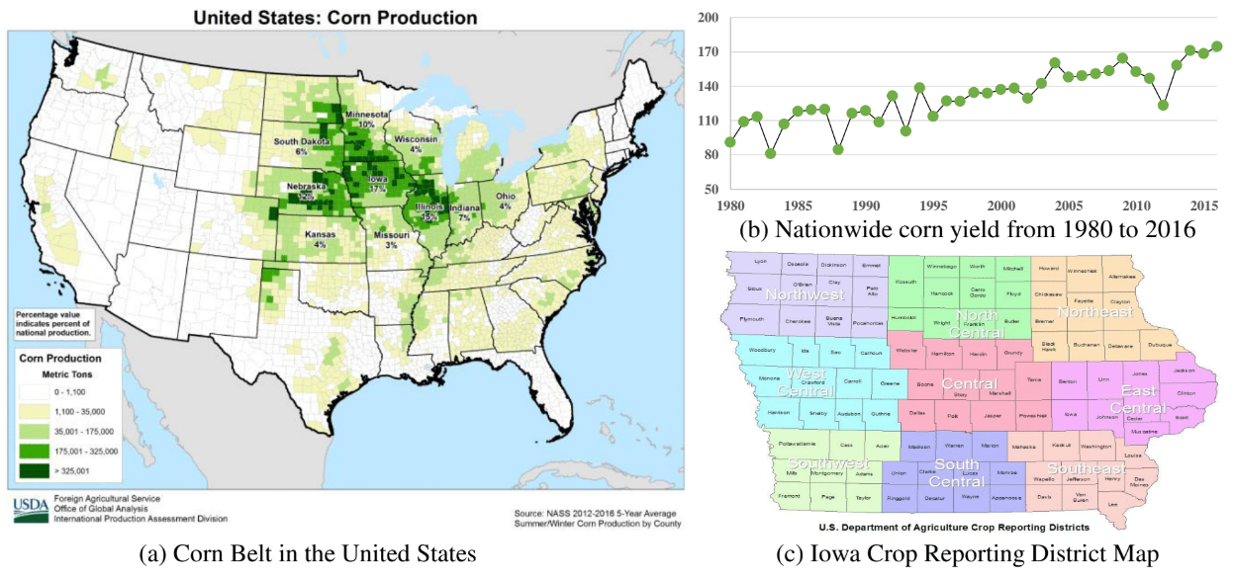
Figure 1 Background introduction.

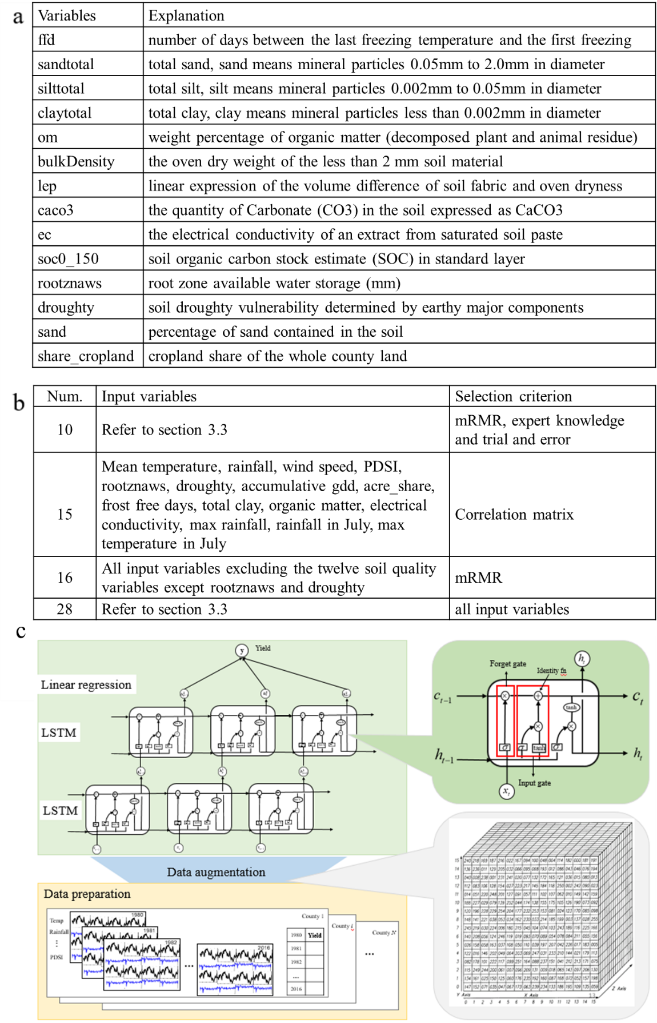
Figure 2 Data preparation and LSTM framework for yield prediction. The description of variables in publicly available data is shown in (a), and the four sets of selected variables are listed in (b) using for inputs of LSTM framework, which is shown in (c) including data augmentation, structure of LSTM unit, and deep LSTM structure.
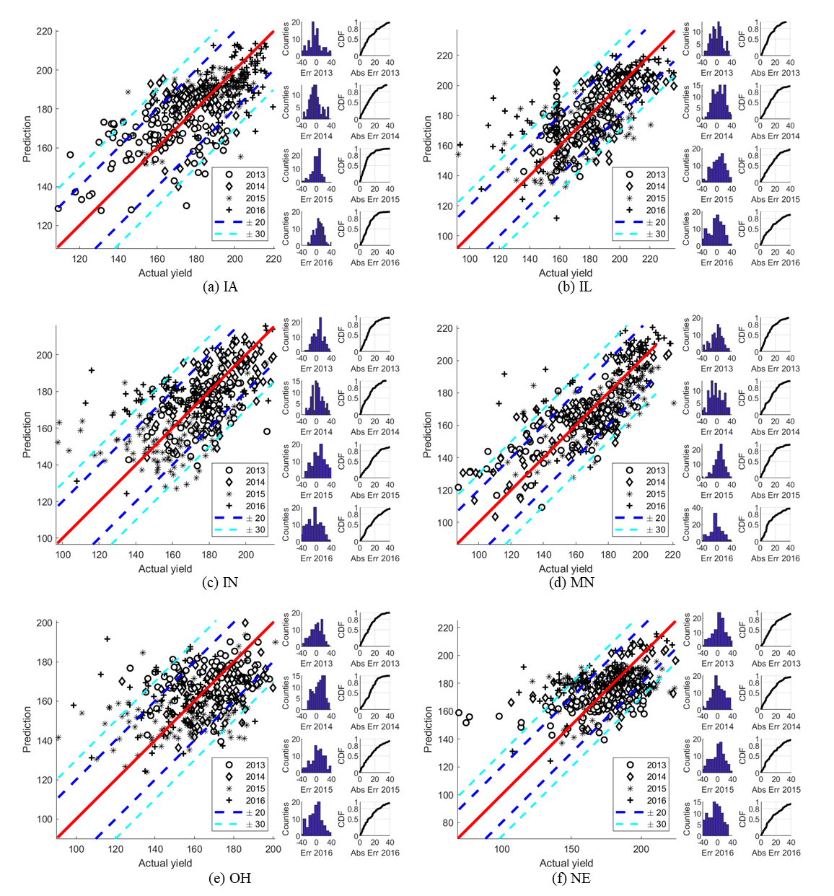
Figure 3: County-level Prediction Results. For each subplot, the left panel shows the prediction vs the actual yield and the error bars in 20 bu/ac and 30 bu/ac are marked in blue and cyan respectively. The right panel of each subplot show the errors of the predicted year (2013-2016).

State | LSTM_NOV |  | NASS_NOV
 | MAE (bu/ac) (bushels/acre) | MAPE (%) | MAE (bu/ac) (bushels/acre) | MAPE (%)
Iowa | 4.31 | 2.29 | 4.37 | 2.41
Illinois | 2.85 | 1.56 | 3.50 | 1.92
Indiana | 2.96 | 1.74 | 3.75 | 2.27
Kansas | 10.14  .6.09 | 6.95 | 4.25 | 3.02
Michigan | 6.09 | 3.79 | 3.25 | 2.03
Minnesota | 4.24 | 2.38 | 4.50 | 2.75
Missouri | 9.92 | 5.88 | 3.25 | 2.06
Nebraska | 3.41 | 1.95 | 2.50 | 1.39
Ohio | 3.42 | 2.01 | 4.00 | 2.56
South Dakota | 7.76 | 5.29 | 6.75 | 4.46
(a)

Year | Yield | LSTM_NOV | NASS_NOV
2013 | 161.78 | 162.90 | 164.29
2014 | 175.60 | 175.44 | 178.49
2015 | 173.10 | 173.40 | 173.04
2016 | 181.09 | 179.34 | 181.54
MAE (bushels/acre) |  | 0.8325 | 1.4475
MAPE (%) |  | 0.48 | 0.87

(b)
Table 1: Corn yield prediction at State and Corn Belt level. In (a), the state-level performance is evaluated with MAE and MAPE metrics, and the performance of NASS predictions are listed in the right panel for comparison. In (b), the corn-belt level performance of the proposed framework is evaluated yearly as well as the predictions by NASS.

Figure 4: Early Yield Prediction Comparison between USDA and LSTM. The yield predictions from August to November by the proposed framework are compared with the ground truth and the NASS predictions, which shows superior performance on early prediction of the proposed LSTM framework.

We try both adjustments in our model; however that raises a few more concerns. Which year should the yield be adjusted to? Will that influence the prediction results? If all yields are adjusted to the 2015 base year, will the 2015 prediction be better than other years? To answer these questions, we train our model with corn yield adjusted to both 2013 and the 2015 base year. The results show that there is no evidence for such concerns. Thus we de-trend all the yield data into 2013 base.
We emphasize that these combination samples are meaningful and reasonable since PDSI is also collected at the CRD level and all other data are also average numbers for county area (the most precise data point should be each farmland, which is not available).
PDSI is monthly data, so it repeats the times of number of days in each month. While rootznaws and droughty repeat 214 times since they are constant.
LSTM is also available for daily prediction. It would be too much work to train separate models for each day to make daily predictions. Therefore, we can use the best model for each state, input known explanatory variables data, and fill unknown data with expected values. Weather and soil humidity data after the date on which the daily prediction is made is the unknown data. The expected input values can be either past 10-year average or from the professional prediction in weather websites/channels if it is available

